LAB #04

Discrete Signal representation in Matlab, Matlab Graphics, Two Dimensional Plots, Plot and subplot, Different Plotting Functions Used in Matlab



Spring 2023

**CSE-301L Signals & Systems Lab**

Submitted by: MUHAMMAD SADEEQ

Registration No.: 21PWCSE2028

Section: C

“On my honor, as a student of the University of Engineering and Technology, I have neither given nor received unauthorized assistance on this academic work”

Submitted to:

Engr. Sumayyea

(20 Mar 2023)

Department of Computer systems engineering

University of Engineering and Technology, Peshawar

**Task 1**

**Code:**

|  |
| --- |
|  |
|  |
|  |
|  |
|  |
|  |
|  |
|  |
|  |

**Output:**

>> T1

Sum :

6 8 10 4 3

Product :

8 15 16 0 0

**Task 2**

**Function Code:**

|  |
| --- |
|  |
|  |
|  |

**Code:**

|  |
| --- |
|  |
|  |
|  |
|  |

**Output:**

>> T2

Signal :

4 8 12

**Task 3**

**Code:**

|  |
| --- |
|  |
|  |
|  |
|  |
|  |
|  |
|  |
|  |

**Output:**

>> T3

index :

1

index :

5

**Task 4**

**Code:**

|  |
| --- |
|  |
|  |
|  |
|  |

**Output:**

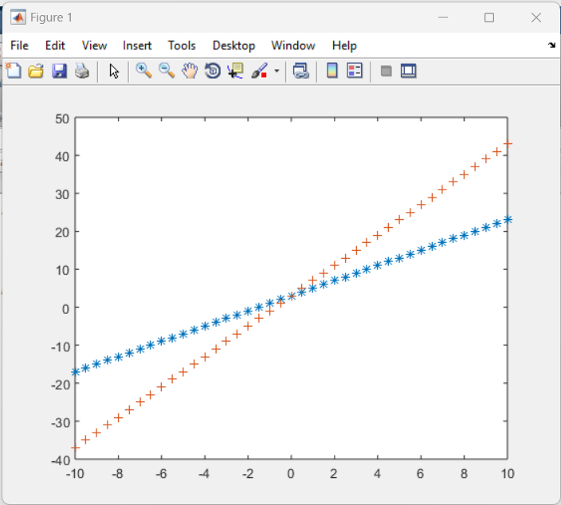

**Task 5**

**Function Code:**

|  |
| --- |
|  |
|  |
|  |

**Function Code:**

|  |
| --- |
|  |
|  |
|  |

**Code:**

|  |
| --- |
|  |
|  |
|  |
|  |
|  |
|  |
|  |
|  |
|  |
|  |
|  |
|  |
|  |
|  |
|  |
|  |
|  |
|  |
|  |
|  |
|  |

**Output:**

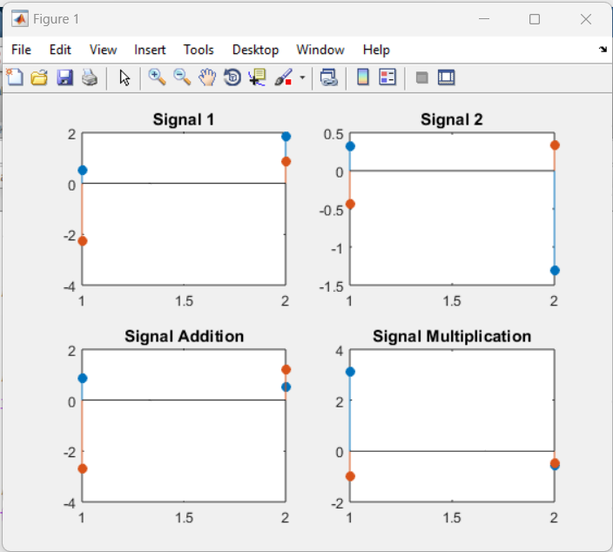

**Task 6**

**Code:**

|  |
| --- |
|  |
|  |
|  |
|  |
|  |
|  |
|  |
|  |
|  |
|  |
|  |
|  |
|  |
|  |
|  |
|  |
|  |
|  |
|  |
|  |
|  |
|  |

**Output:**

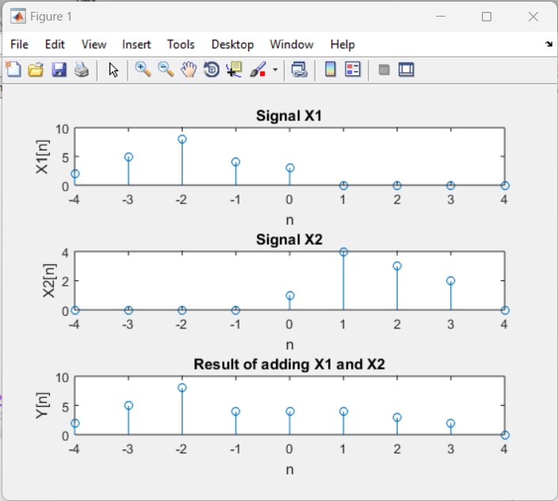

**Task 7**

**Code:**

|  |
| --- |
|  |
|  |
|  |
|  |
|  |
|  |
|  |
|  |
|  |

**Output:**

**>> T7**

Enter signal : [-6 4 2 1 4 ]

count :

3

**Task 8**

**Function Code:**

|  |
| --- |
|  |
|  |
|  |

**Function Call Code:**

|  |
| --- |
|  |
|  |
|  |
|  |
|  |
|  |
|  |
|  |
|  |
|  |
|  |
|  |
|  |

**Output:**

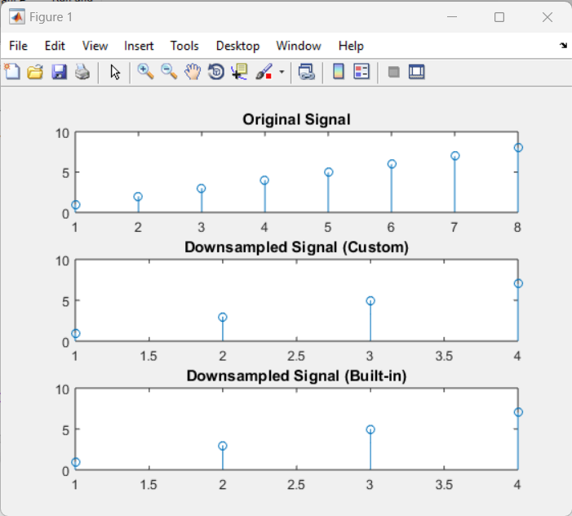

**Task 9**

**Function Code:**

|  |
| --- |
|  |
|  |
|  |
|  |
|  |

**Function Call Code:**

|  |
| --- |
|  |
|  |
|  |
|  |
|  |
|  |
|  |
|  |
|  |
|  |
|  |
|  |
|  |
|  |
|  |
|  |
|  |
|  |
|  |
|  |

**Output:**

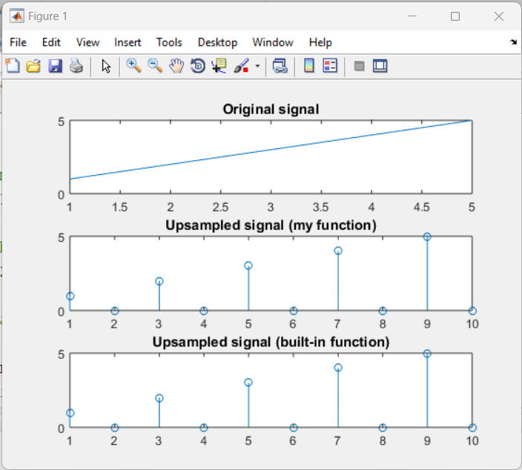

**Task 10**

**Code:**

|  |
| --- |
|  |
|  |
|  |
|  |
|  |
|  |
|  |

**Output:**

